**Name: VYSHNAVI BABU S**

**Roll No: 55**

**Batch: B**

**Date: 24-03-22**

**NETWORKING & SYSTEM ADMINISTRATION LAB**

**Experiment No.: 3**

**Aim**

Familiarization of basic Linux commands.

**Procedure**

1. **pwd** : stands for ‘print working directory’. It gives information about the

directory where the user is working currently.

**Syntax : $ pwd**

**Output :**

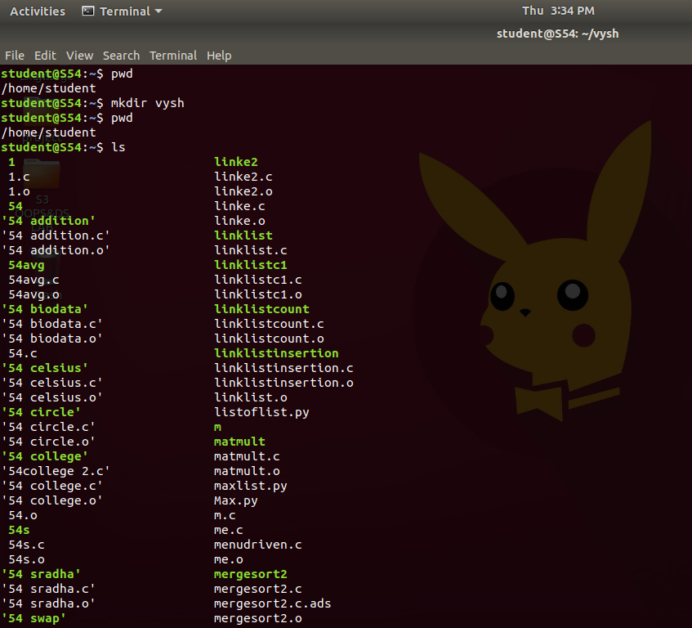

1. **mkdir** : used to create a folder or a directory.

**Syntax** : $ mkdir [folder name]

**Output:**



1. **ls :** This command lists files and directories within the file system, and

shows detailed information about them.

**Syntax : $ ls**

**Output :**



1. **ls -l :** it refers to long listing of information. This shows a lot more

information.

**Syntax : $ ls -l**

**Output:**

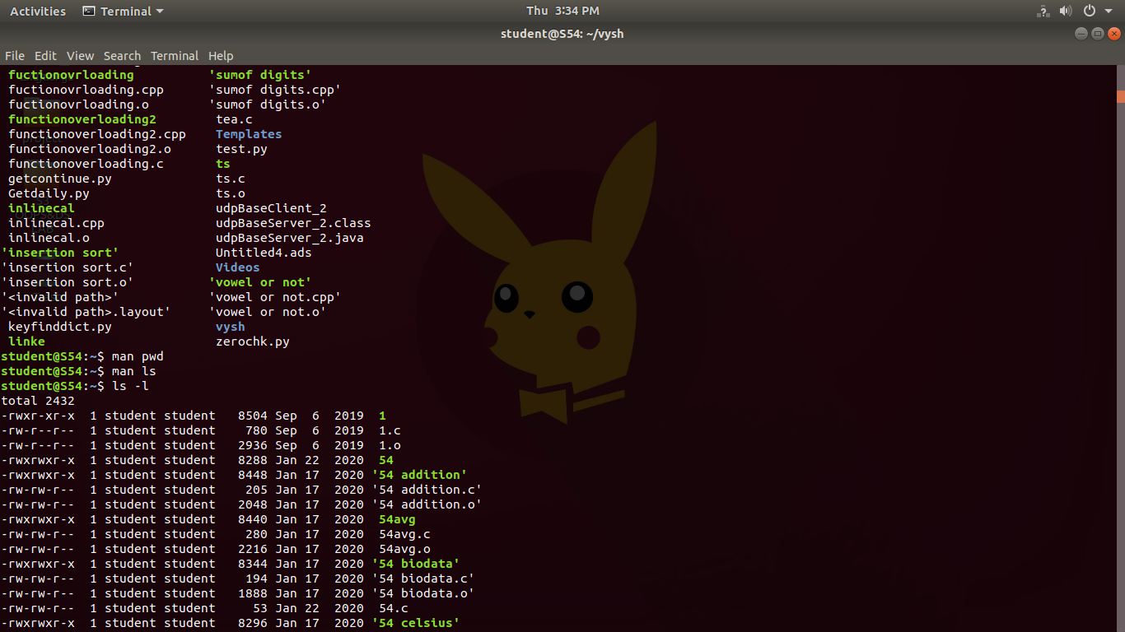

1. **ls -R :** it will display the content of the sub-directories also.

**Syntax: $ ls -R**

**Output:**

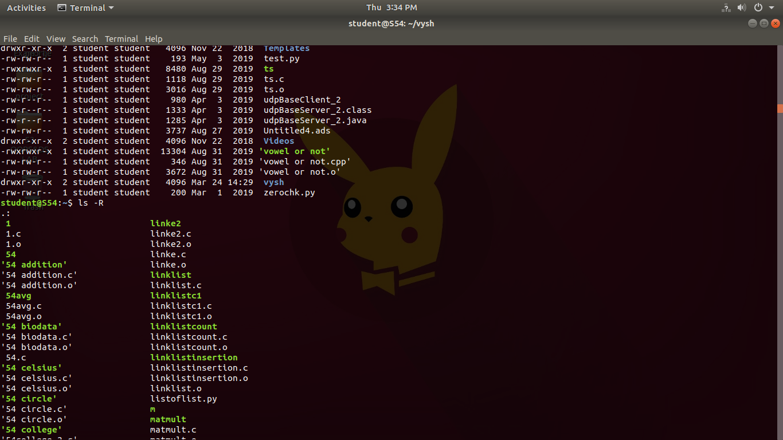

1. **ls -a :** thiscommand will enlist the whole list of the current directory including the

hidden files.

**Syntax: $ ls -a**

**Output:**

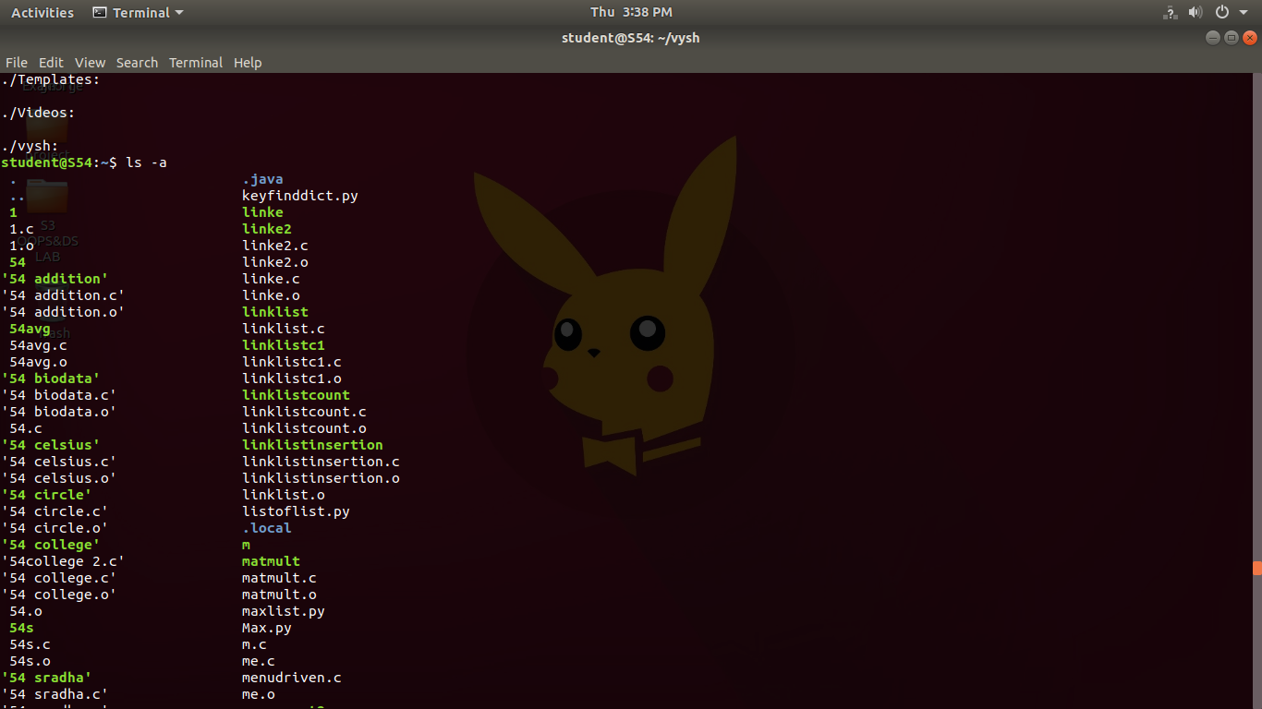

1. **ls -al** : it display all files and subdirectories in the current directory, including

hidden files ,permissions etc..

**Syntax: $ ls -al**

**Output:**

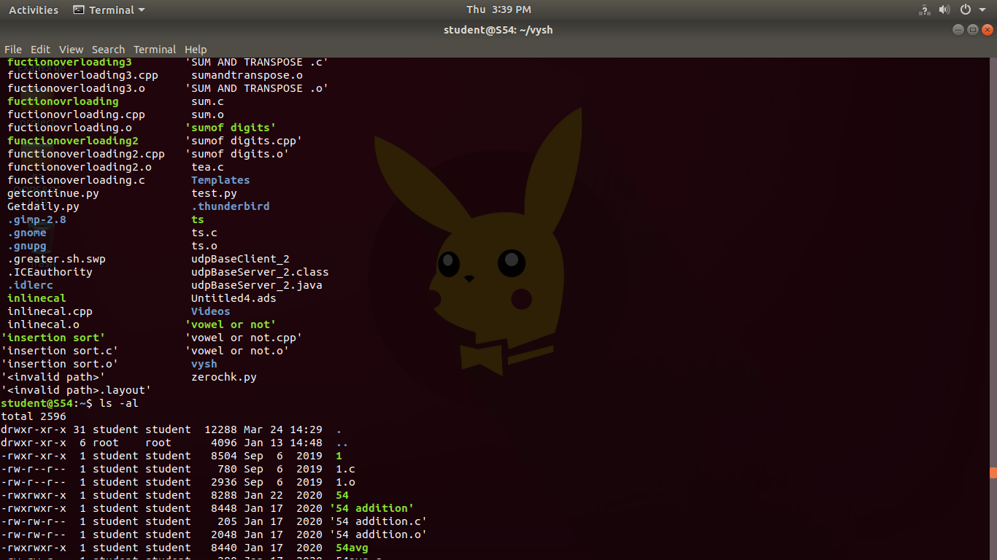

1. **ls -t :** it list the files/directories in last modified order.

**Syntax:** **$ ls -t**

**Output:**

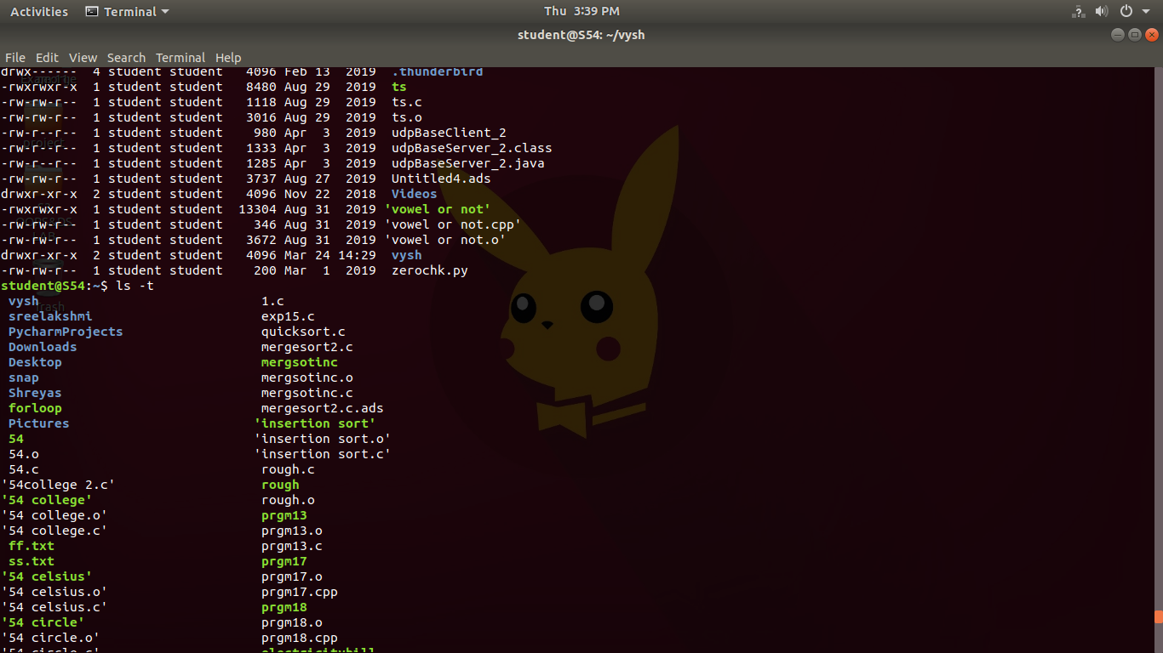

1. **cd :** is used to change the current working directory ( i.e., in which the current

user is working). The "cd" stands for **'change directory**.'

**Syntax: $ cd [file name]**

**Output:**

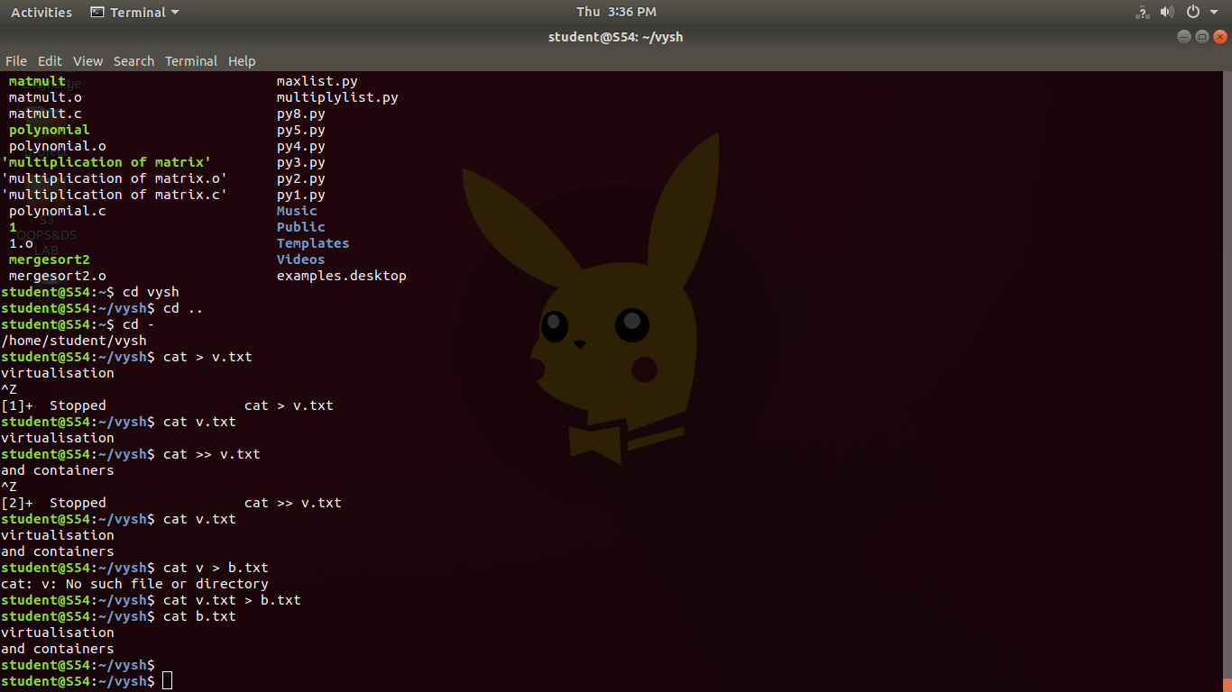 **10. cd .. :** to navigate up one directory level.

**Syntax:** **$ cd ..**

**Output:**



**11. cd - :** to navigate to the previous directory (or back).

**Syntax: $ cd –**

**Output:**



**12**. **cat > filename .txt :** a new test file can be created and then content can be

entered.

**Syntax : $ cat > filename.txt**

**Output:**



1. **cat filename.txt** : the content of the test file created, can be displayed.

**Syntax : $ cat filename.txt**

**Output:**



1. **cat >> filename.txt :** more contents can be added to the test file created.Then the

newtest file formed is displayed.

**Syntax : $ cat >> filename.txt**

**Output:**



**15. cat file1.txt> file2.txt :** used to copy a source text file to another one and then

content of the new file can be displayed.

**Syntax**  : **$ cat file1.txt> file2.txt**

**Output:**

